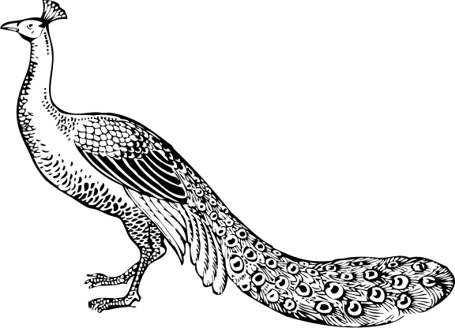

“THE WAY YOU MOVE ME, IT’S CRAZY

IT’S LIKE YOU SEE RIGHT THROUGH

ME AND MAKE IT EASIER

BELIEVE ME, YOU DON’T

EVEN HAVE TO TRY

BECAUSE YOU ARE THE BEST THING

THAT EVER HAPPENED TO ME”

Ray LaMontagne

THE

WEDDING CEREMONY

OF

Yasmin

&

Sean

THE THIRTEENTH OF OCTOBER

TWO THOUSAND AND TWELVE

AT FIVE O’CLOCK IN THE AFTERNOON

MANSION AT JUDGES HILL

AUSTIN, TEXAS

The Peacock

THE PEACOCK IS A BIRD OF PROTECTION AND SAFE GUARDING AND REPRESENTS FIDELITY, GOOD LUCK, HARMONY, AND SERENITY. AS PEACOCKS ARE PURE AT HEART, LOYAL, AND FAITHFUL TO THEIR PARTNERS, THEY ALSO SYMBOLIZE ETERNAL LOVE.

Thank You

WE WOULD LIKE TO THANK EVERYONE FOR COMING TODAY. we would like to express our sincerest thanks to all of you for helping us make this day a joyous celebration, especially our parents who gave us life; our families who shared our life; our relatives and friends who helped us grow up to this special day. YOU ARE TRULY A PART OF OUR HEARTS AND WE LOOK FORWARD TO SHARING THIS AND MANY, MANY MORE MEMORIES THROUGHOUT OUR LIVES.

In Remembrance

WE WOULD LIKE TO HONOR AND LOVINGLY REMEMBER THOSE WHO COULDN’T BE WITH US TODAY.

Music

SOULFULLY PROVIDED BY “NAME”

CELLO

Name

GUITAR

Name

Wedding Party

OFFICIANT

Reverend so and so

PARENTS OF THE BRIDE

Jaime and Martha Staalenburg

PARENTS OF THE GROOM

Jack and Leila Hall

MAID OF HONOR

Jennifer Gruninger

BEST MAN

Nathaniel Johnson

BRIDESMAIDS

Marisol Benton

Jami Griggs

Jennifer Gruninger

GROOMSMEN

Trent Burk

Edwin Davila

Audrey Taylor

Dylan Price

Flow of Wedding Ceremony

prelude

“air on the g string”

processional

“canon in D”

“air from water music”

bridal processional

“bridal chorus”

greeting, and opening prayer

“our love” by kahlil gibran

read by maid of honor

rite of marriage

exchange of vows

blessing of the rings

sand ceremony

first kiss, sign of peace to all

wedding prayer

lords prayer

signing of the documents

“ave maria”

recessional

“trumpet voluntary”

postlude

“arrival of the queen of sheba”

Our Love by

Kahlil Gibran

You were born together, and together you shall be forevermore.  
You shall be together when the white wings of death scatter your days.  
Ay, you shall be together even in the silent memory of God.  
But let there be spaces in your togetherness,  
And let the winds of the heavens dance between you.   
  
Love one another, but make not a bond of love:  
Let it rather be a moving sea between the shores of your souls.  
Fill each other's cup but drink not from one cup.  
Give one another of your bread but eat not from the same loaf  
Sing and dance together and be joyous, but let each one of you be alone,  
Even as the strings of a lute are alone though they quiver with the same music.   
  
Give your hearts, but not into each other's keeping.  
For only the hand of Life can contain your hearts.  
And stand together yet not too near together:  
For the pillars of the temple stand apart,  
And the oak tree and the cypress grow not in each other's shadow.